Visit to Nortel - Ottawa
Apr. 28 and Apr.29 2006

StarPlane roadmap:
Summary of discussion between UvA and Nortel

Version 1.: Paola Grosso – SNE group, UvA

This is a summary of the discussion we had on StarPlane future roadmap on Friday April 28 in Ottawa. This was primarily a brainstorming session intended to clarify where we stand currently, and what are the future developments ahead of us in the design and implementation.

UvA people: Cees de Laat, Leon Gommans, Paola Grosso, JP Velders, Li XU
Nortel people – Eric Bernier, Evelyn, David, David, Giuseppe

CPL control plane architecture

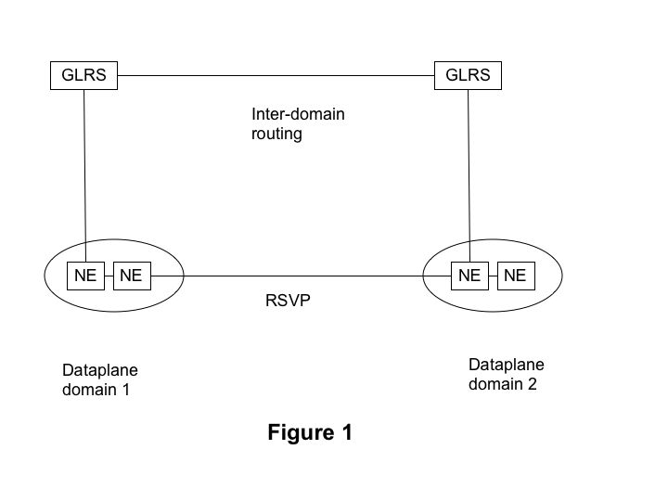
Nortel initial idea for the CPL control plane was to have a separate GLSR (Generalized Label Switching Router) control the NEs (Network Element). This model is shown in Fig.1 for a case in which multiple domains interact with each other. Each dataplane communicates via RSVP to provision the inter-domain path.
Each NE consists of an OSC and WSS.

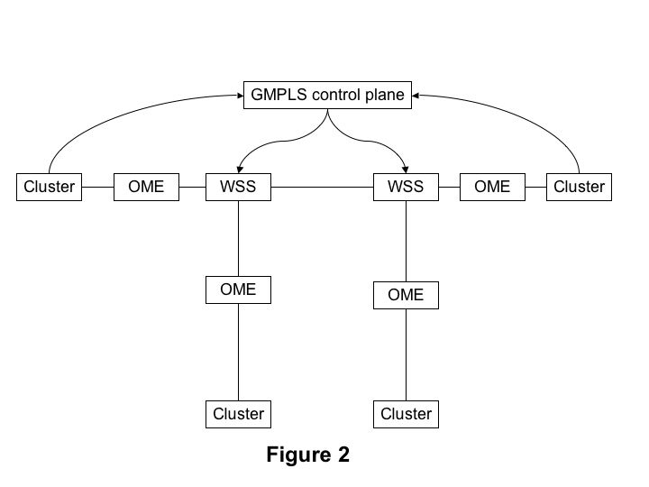
Deviating slightly from the original model, in the most current implementation of the control plane the GMPLS implementation and functionalities have been move into the NEs directly. There is not any longer a separate GLSR, but its functions are embedded in the NEs.
The GLSR software on the NEs will initially directly interact with the user/application.

We can see in Fig.2 a more detailed overview of the CPL control plane. The cluster and the applications that run on them will communicate with the GMPLS control plane; the GMPLS control plane will talk to the WSS.

The communication between the StarPlane GLER (Generalized Label Edge Router) and the Nortel GLSRs will go via RSVP. Each GLER talks to the closet GLSR; there is a GLSR in each DOC.
Figure 1 - GMPL control plane - detail

In the future the interaction between application and the GLSR will be mediated via DRAC. This is shown later on in Fig. 4.

Development timeline
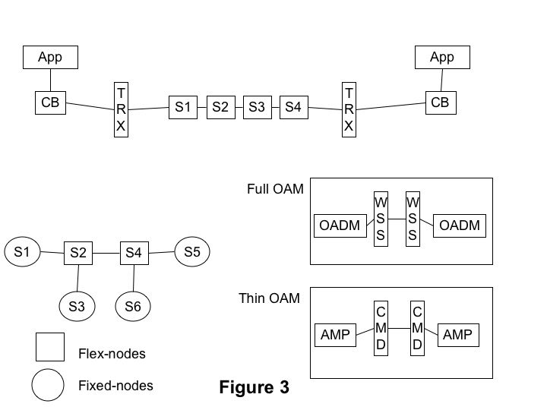
To provide complete separation between production environment and StarPlane we will initially work in a sandbox. Essentially Nortel will provide SURFnet with a safety switch that can turn off StarPlane capabilities to make changes. SURFnet will use this feature during their schedule maintenance and reconfiguration windows.

There are two phases relative to Nortel delivery of hardware and software components:
- Phase 1 will go live at the begin of July ’06;
- Phase 2, with non-static GMPLS, will start at the end of 2006 with completion expected in April 2007. The software load with the GLSR software embedded in the NEs will be available in the fall of 2006.

Phase 1 physical architecture is shown in Fig.3. There are two kinds of nodes/DOC. Fixed-nodes and flex-nodes. The flex-nodes can be controlled and “manipulated” by StarPlane. They constitute the sandbox, and they are located at Amsterdam1 and Amsterdam2.
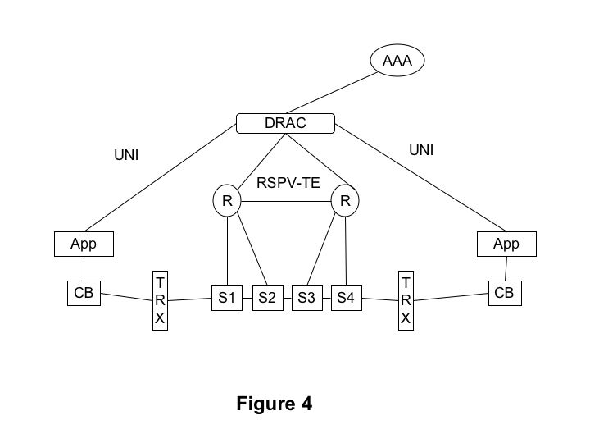
When we will reach Phase 2, with control plane in the OSC, the application will communicate via the cluster backend (CB) directly to the NEs in the various sites.
As we mentioned before, the future design of the Control Plane will involve the interaction of the application with DRAC via UNIs. DRAC will communicate with the GLSR and interact with the AAA. This is shown in Fig. 4.

Open issues:
There are three issues we need to consider more carefully,
- Sub-seconds switching: How do make the Starplane architecture achieve the subsecond switching? There were several points we touched on, and we did not reach a conclusion. We do not expect that the control plane software will be the bottleneck in this case; the “slowness” in the changes will be hardware related. We discussed several ways to achieved an increased switching time in the hardware, but we did not reach a conclusion on how this will be effectively done.

- Contention: How do we take care of duplicate requests or requests for the same resources? This will be handled by RSVP-TE messages between NEs;

- Path and data-plane setup: how do we know when traffic can flow though a path that has been reserved and acknowledged? We will need ways to distinguish between the reservation of the path and the acknowledgement of the setup form the control plane and the actual setup of the data-plane. Pinging the other side of the lightpath?

Authorization model
One the important design issues we need to take into account is authorization and authentication. We (UvA) showed to Nortel the authorization models described in RFC 2904.

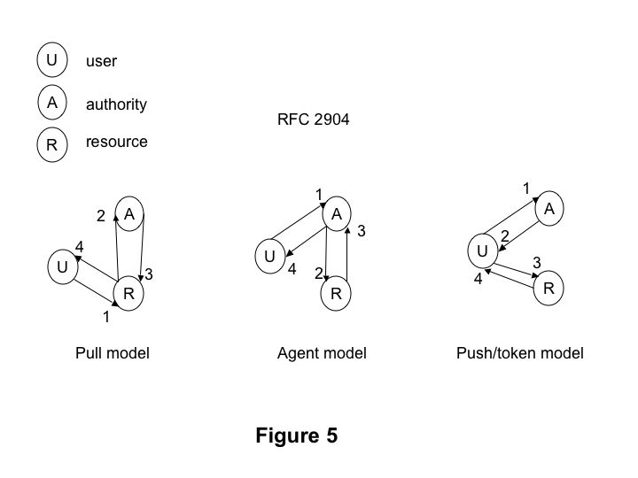
There are the interaction model between an user, the authority and the underlying resources: the pull model, the agent model and the push(or token) model. They are shown in Fig.5.

We agreed that the agent model and the token model are the two models that could be used within StarPlane.
We need to work together on a sequence document in which we outline the steps necessary to provision an end-to-end path from the perspective of the user/application and the authority and the resources. After this document we could then look at complete architectural document.

Action points
We discussed ways forward. Especially possible cooperation in the short term.
What can we do in the next year before we get full delivery of GMPLS code in the NEs?
One possibility is for the UvA to get access to the GMPLS simulation boxes in the Nortel lab in Canada. That would allow us to see what are the functionalities available, if they satisfy the requirements from our application.
Nortel was going to look at how to get us access to the simulator.

